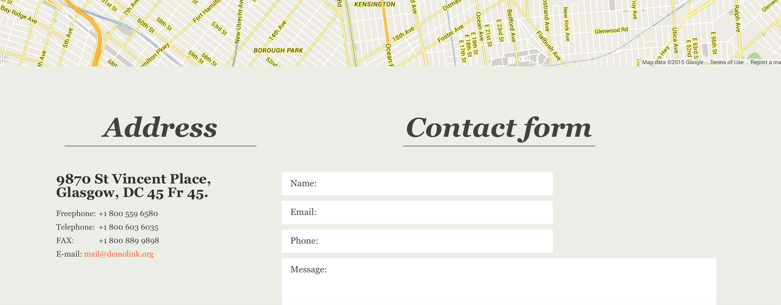

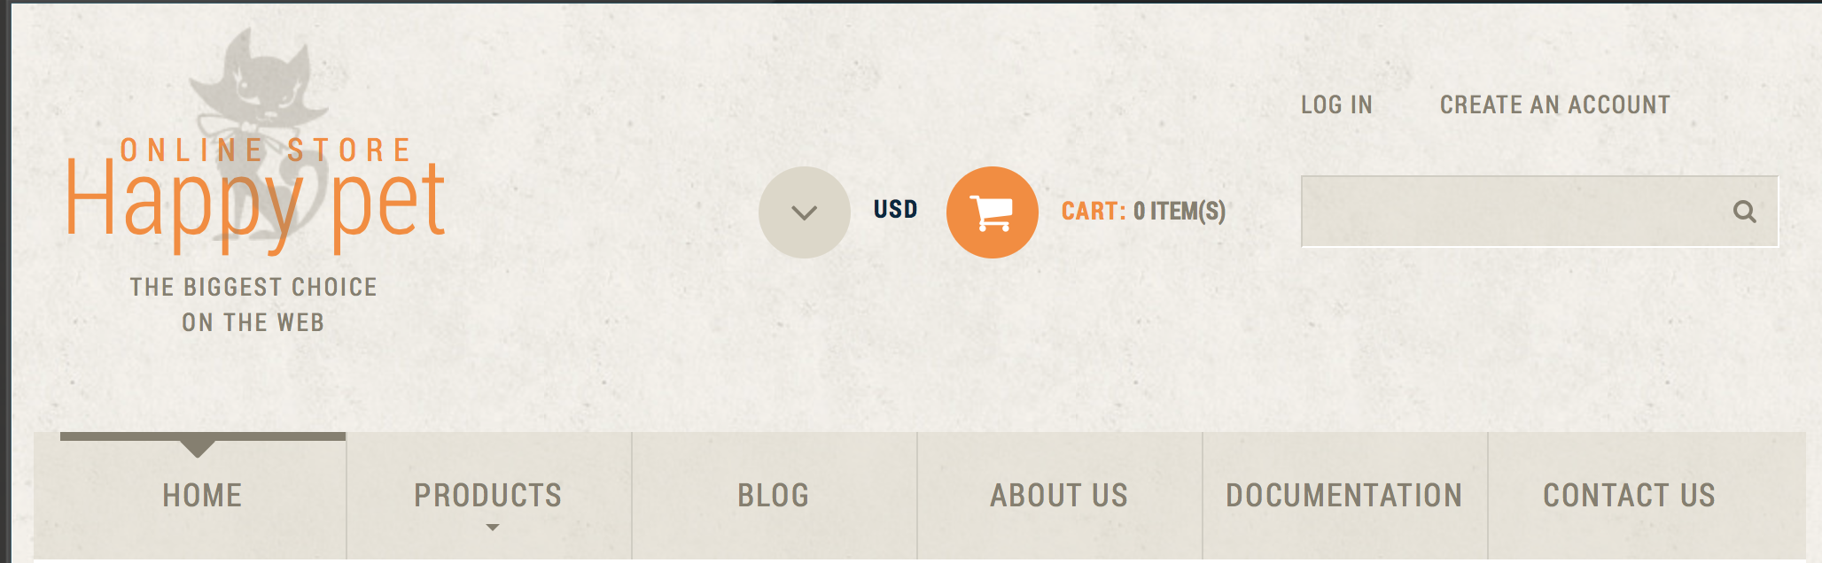

I liked both of these, (contact form and login) because of the neutral color choice and the simple style. #1 pulls up a full map showing the exact location without having to map it in a separate window, which I find helpful. The contact form is clean and simple.

#2 has the same feel to it. Beautiful neutral colors with a touch of bright orange to bring certain things to the eye. Everything you need to know is in the top third of this page. I feel like the login could have been used a little of the orange color to being it out more but overall, I liked this site.